**PoD Attendance Bot.**

This is a service to simplify and centralise the attendance taking process within People of Destiny (PoD), so that Shepherds can understand member patterns and take proactive steps to encourage them.

Hebrews 10:25 says *"Let us not give up meeting together, as some are in the habit of doing, but let us encourage one another—and all the more as you see the Day approaching".*

Here’s how it works.

⛪️

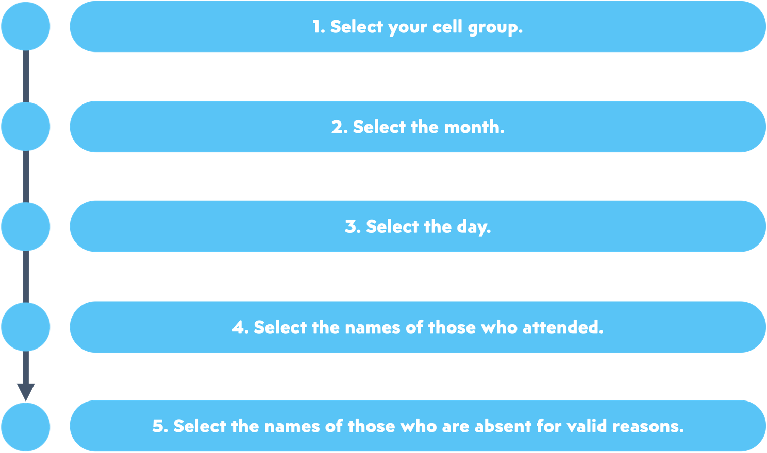

**How do we**

**add new friends?**

**To add new friends, simply spell out their names (preferably first & last names) in step 4’s list of attendees,**

**e.g. Nehemiah Tan.**

🥳

